**Class 14**

JENKINS

-> it’s a ci/cd tool

* Ci – Continuous Integration: Continuous build + Continuous testing old code with new code

Before ci we have lots of time waste and every thing is manual work .

After ci everything is automated.

* CD - Continuous Delivery: deployment manually to production environment

- Continuous Deployment: deployment automatically to production environment

* PIPELINE: Step by step execution of a particular process.

Series of events interlinked with each other.

CODE - - > BUILD - - > TEST - - > DEPLOY

ENV :

DEV : DEVELOPERS

QA : TESTERS

UAT : CLIENT

THE ABOVE ENVS ARE CALLED AS PRE – PROD OR NON – PROD

PROD : USER

PROD ENV IS ALSO CALLED AS LIVE ENV

JENKINS :

It’s a free and opensource tool.

Its platform independent.

It is built on java – 1.

It consists of lot of plugins.

Port no of Jenkins is 8080

SETUP: CREATE EC2 WITH ALL TRAFFIC (8080)

#STEP-1 :

yum install git java-1.8.0-openjdk maven -y

#STEP-2: GETTING THE REPO (jenkins.io --> download -- > redhat)

sudo wget -0 /etc/yum.repos.d/jenkins.repo https://pkg.jenkins.io/redhat-stable/jenkins. repo

sudo rpm --import https://pkg.jenkins.io/redhat-stable/jenkins.io-2023.key

#STEP-3: DOWNLOAD JAVA11l AND JENKINS

amazon-linux-extras install java-openjdkll -y

yum install jenkins -y

update-alternatives --config java

#STEP-4: RESTARTING JENKINS (when we download service it will on stopped

state)

systemctl start jenkins.service

systemctl status jenkins.service

COPY PUBLIC ID AND PASTE ON BROWSER LIKE THIS  
public-ip : 808 0

->Jenkins will started and it wil ask for a password -> copy the path given and then paste it in instance as  
cat cat /var/lib/jenkins/secrets/initialAdminPassword  
click on install

Install plugins and create user for login.



NEW ITEM -- > NAME: NETFLIX JOB -- > FREE STYLE -- > OK

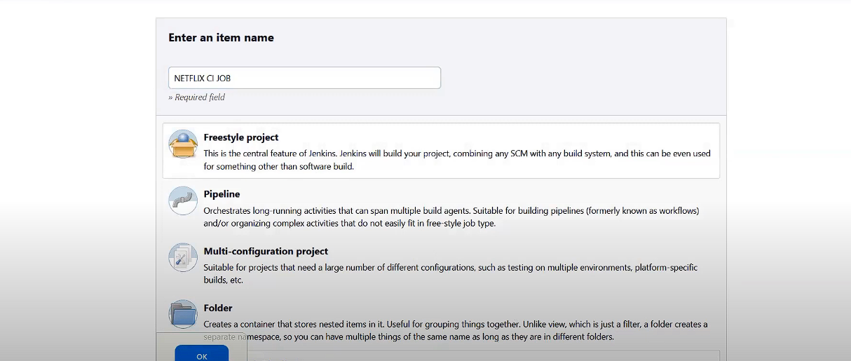

SOURCE CODE MANAGEMENT -- > GIT - - > <https://github.com/devopsbyraham/jenkins-java-project.git>



CLASS 15

SETTING UP JENKINS AUTO

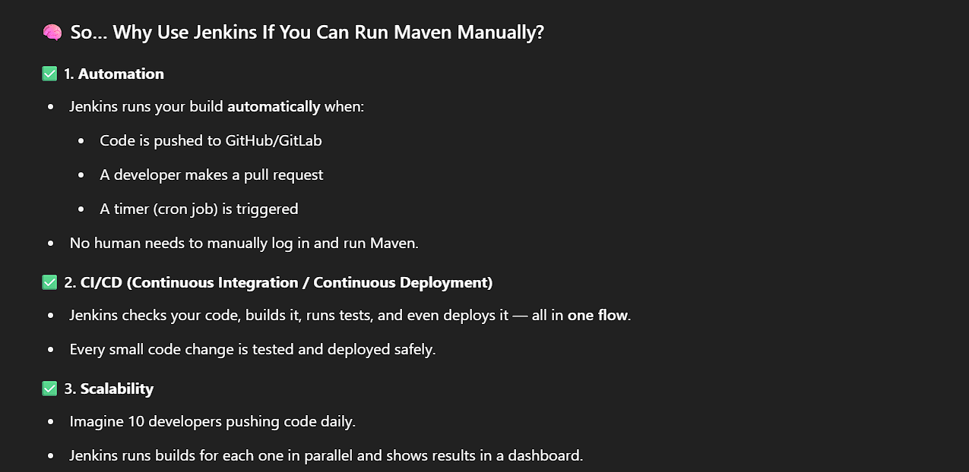  
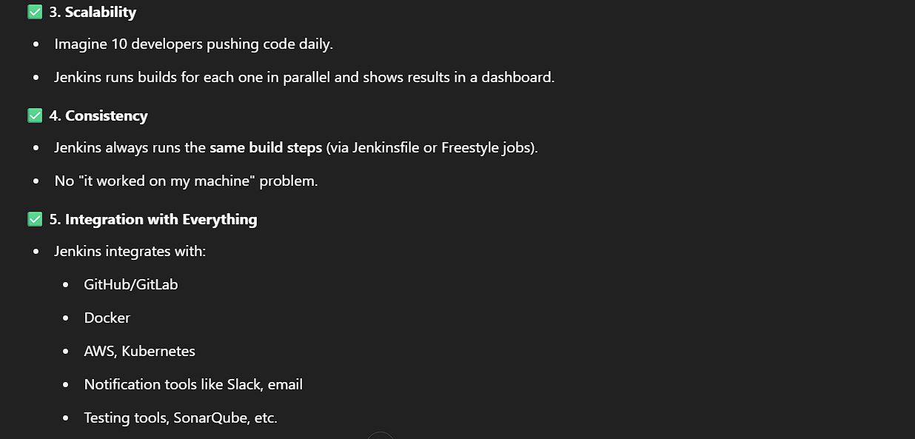

Step to setup :

Make a file vim Jenkins.sh  
in file editor paste all the scripts   
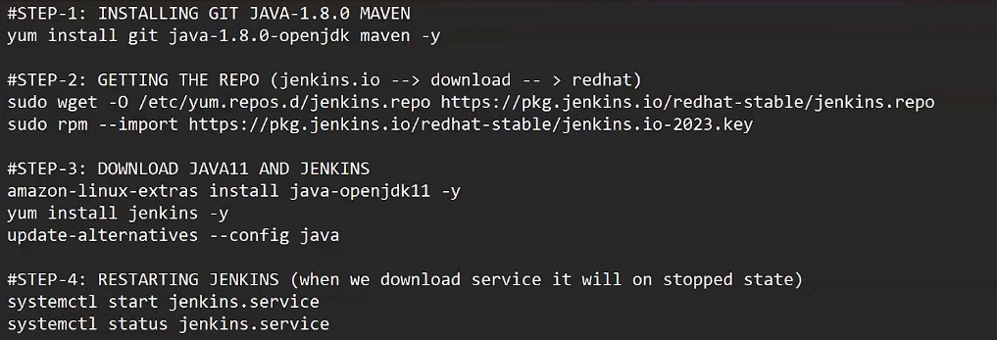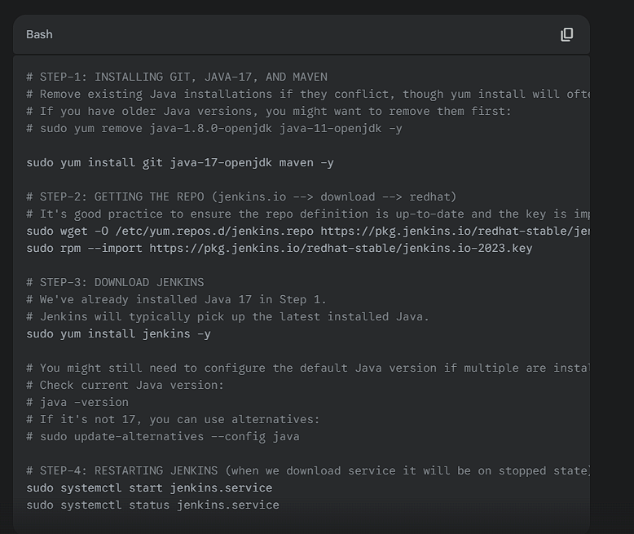

then   
write command   
sh Jenkins.sh  
  
and after that   
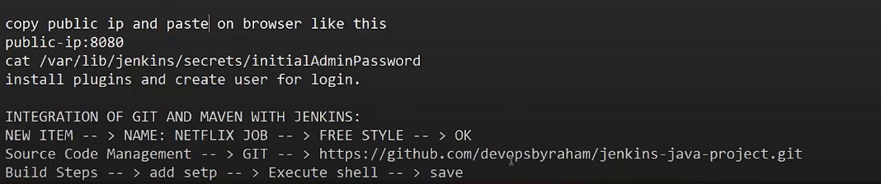

note – here you will see the disk space problem in Jenkins - > go to shell and using command giv ethe tmf the whole disk space

first try this :sudo rm -rf /tmp/*

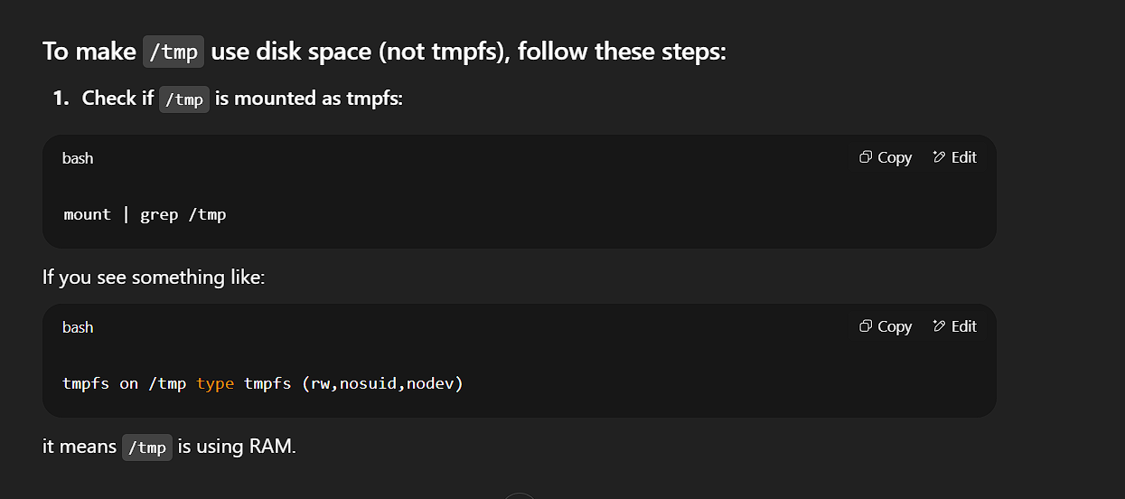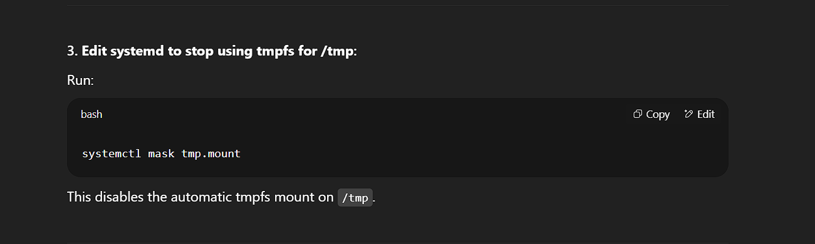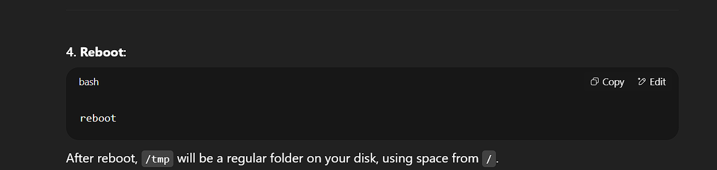it should be running fine now

sudo systemctl mask tmp.mount

sudo reboot

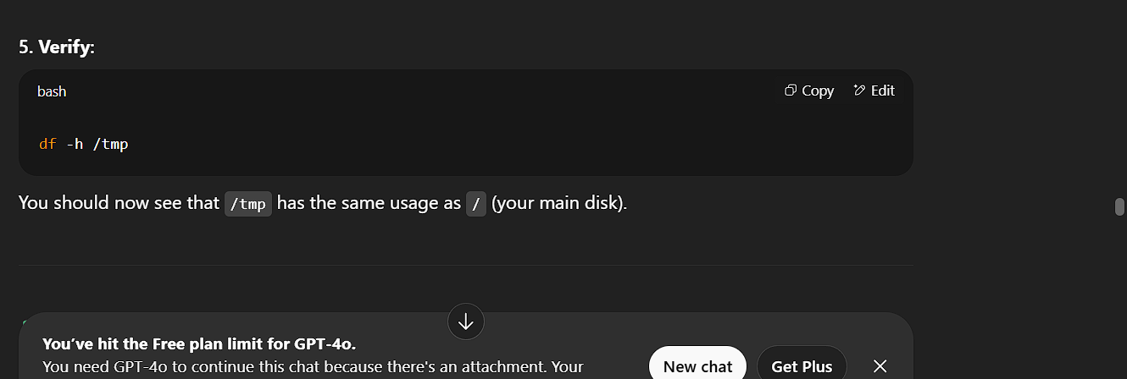  
  
  
types :

1. CHOICE : WHEN WE HAVE MULTIPLE OPTION WE CAN SELECT ONE ONLY

99 % we are going to use this parameter  
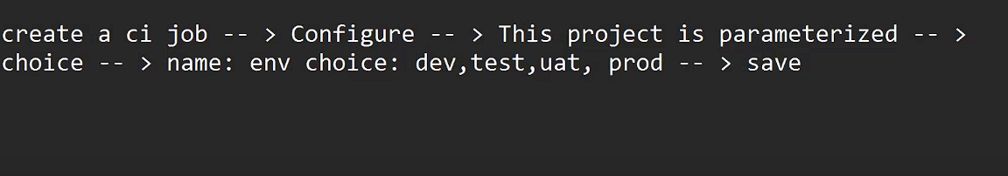  
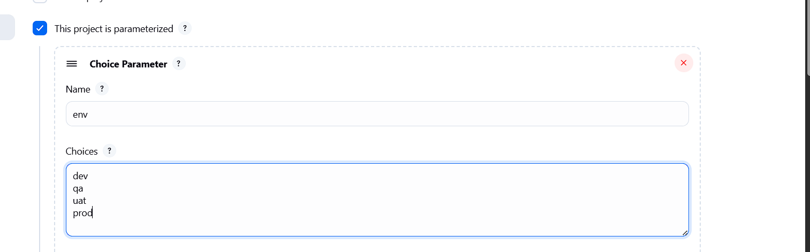

1. STRING : to pass multiple inputs -rarely use
2. Multiline strings : to pass inputs on multiple lines
3. Boolean : when you have only two options take it orllllllllll not(true or false)
4. FILE : it will ask you to upload file – to build files  
   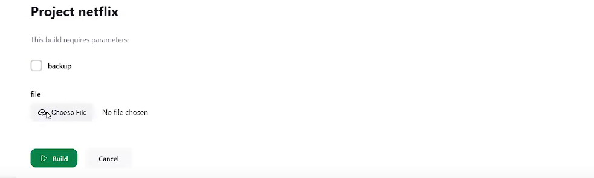

PORT CHANGING :   
go to path ->   
vim /usr/lib/systemd/system/jenkins.service  
-> go to line 67 (:67)  
change the port no. to 8080 = 8090  
save

Now run command  
systemctl daemon-reload

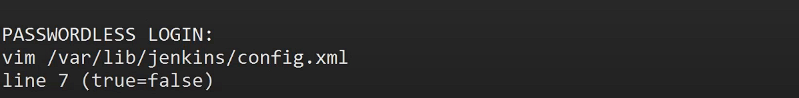

**.**

**CHANGING BUILD LIMITS:**

Go to dashboard -- > manage Jenkins - - > nodes -- > built-in nodes - - >

Configure - - > number of executors - - > 3 - - > save

NOTE: (how to resolve server crash )  
stop the instance - > rerun the instance -> connect it - > copy public ip -> rerun jenkins - > paste the new ip : 8080(port no. )

when we stop and start server your ip will change and the services

inside server also stop.  
  
HOW TO RECOVER THE ACCIDENTAL DELETION :  
Dashboard -- > Manage Jenkins -- > Plugins -- > available plugins -- >Job Configuration History -- > install -- > go back to top page  
now to try to delete a job

**CLASS 16**

CRONJOB

-> used to schedule the work on Jenkins.

cron syntax is used to work with cron jobs .

cron syntax : ***** 5 stars

each star will have space in between

* first star – minutes

* second star - hours

* third star – date

* forth star – month

* fifth star – day (0 = sun , 1 = mon, … )

Note -> use server time (utc)

Eg – 05:50 18-06-2025

50 5 18 9 6 3

NOTE – THERE IS A WEBSITE CALLED crontabgenerator – it will generate you a cron syntax for you

Create a ci job

Go to configure - > build trigger -> build periodically - >write the cron syntax * * * * * - > save

LIMITATIONS :

Let say you schedule a job and that time theres no commit happens to the code then build will trigger and your .war file will be of no use  
 1. Will not check the code is changed or not .

For that purpose we use :

**POLLSCM** : it will build when code is changed only .

Note – you need to set the time limit

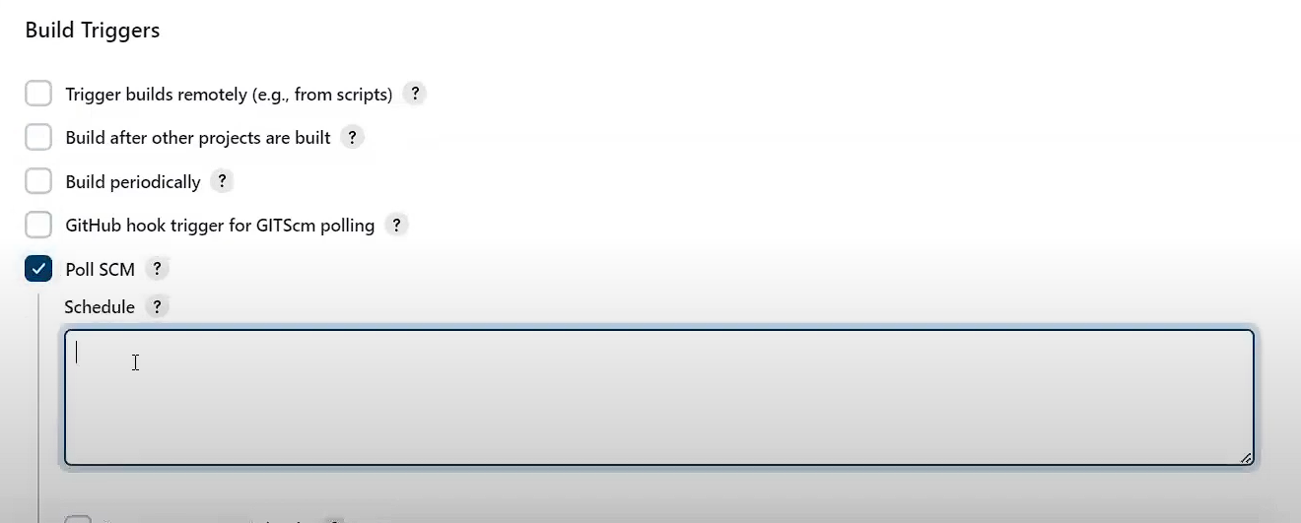

LIMITATION : lest say I schedule at 9 am tomorrow but developer pushes the code at 7 am so now he have to wait for tow hours now   
 -> to tackle this we will use   
  
WEBHOOKS : it will trigger the build the moment we commit the code

STEPS :

1. Go to GitHub - > REPO - >settings - > webhook -> add webhooks - > payload url : jenkinsUrl -> give your Jenkins url

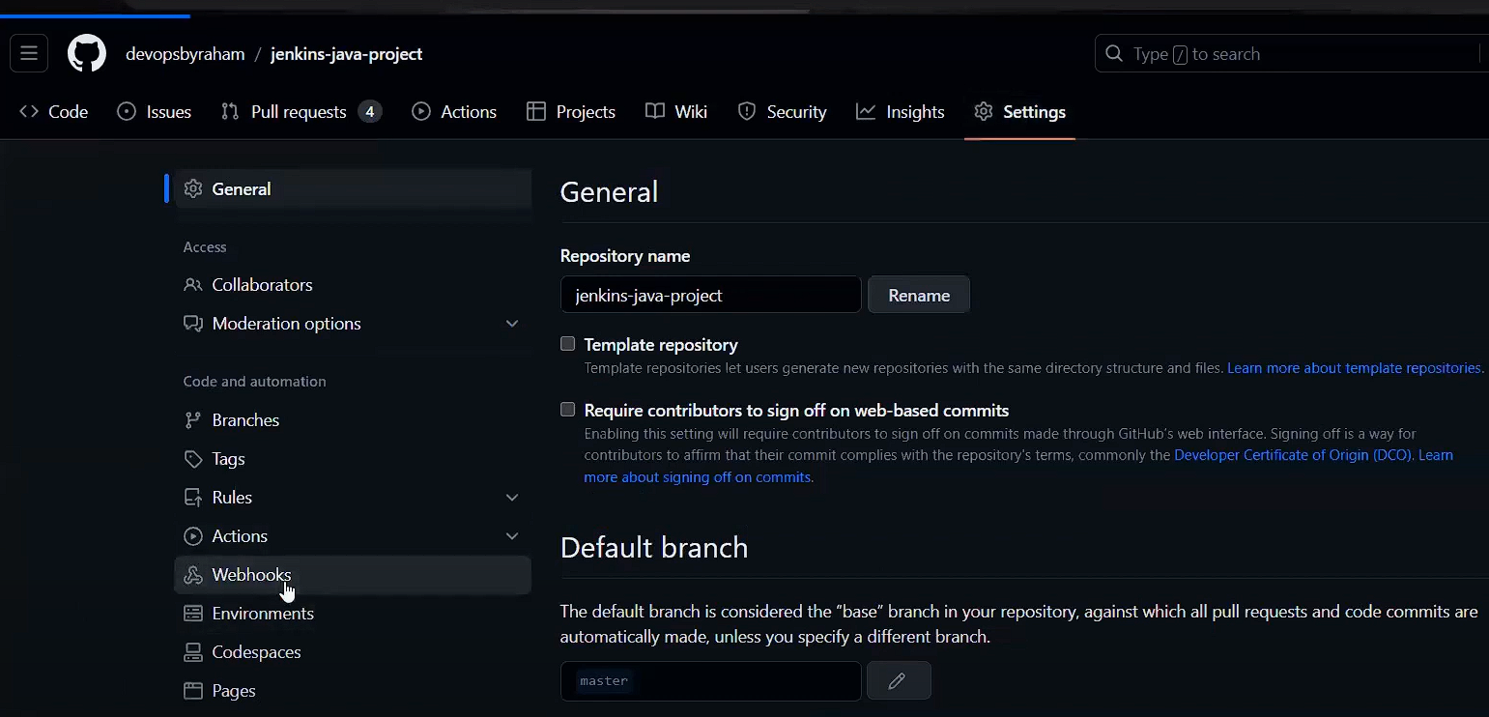

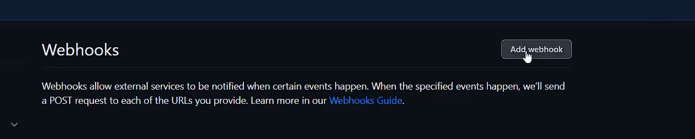  
2. and paste url with suffix as shown   
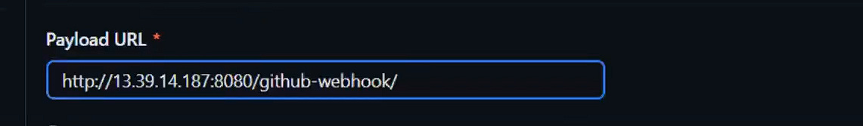

1. Content type - > select application/ json   
   



1. Jenkins Dashboard -- > create ci job again - > git - > build step - > maven -> build trigger -> save  
   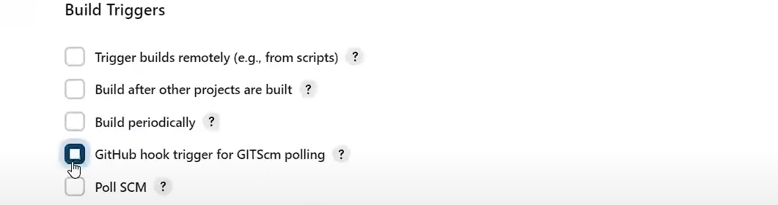

NOW WHENEVER YOU COMMIT THE BUILD WLL TRIGGER

**THROTTLE BUILD**

To set buid per time :

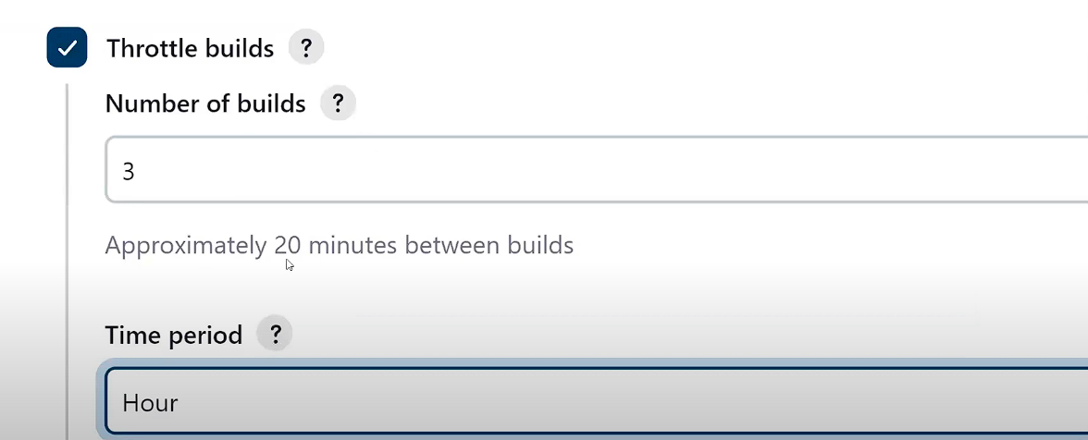  
if we try to build more then 3 now it will go to pending status for an hour coz we set 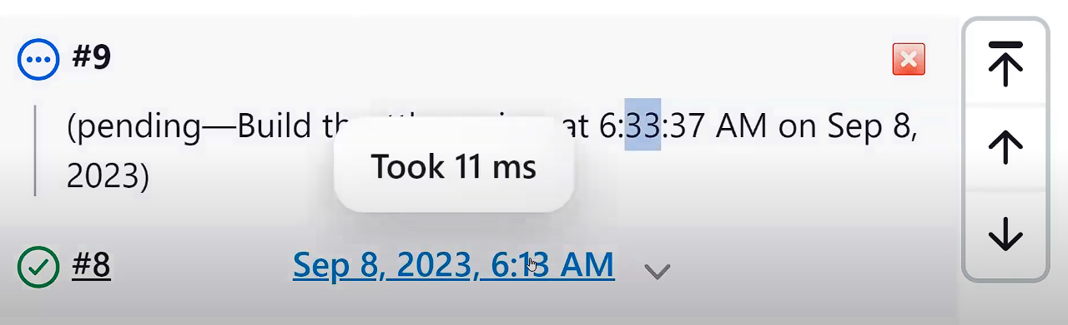 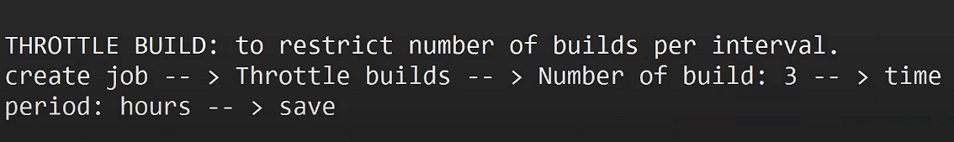

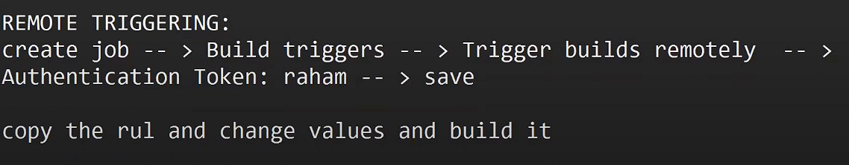

CLASS 17

**MASTER AND SLAVE**

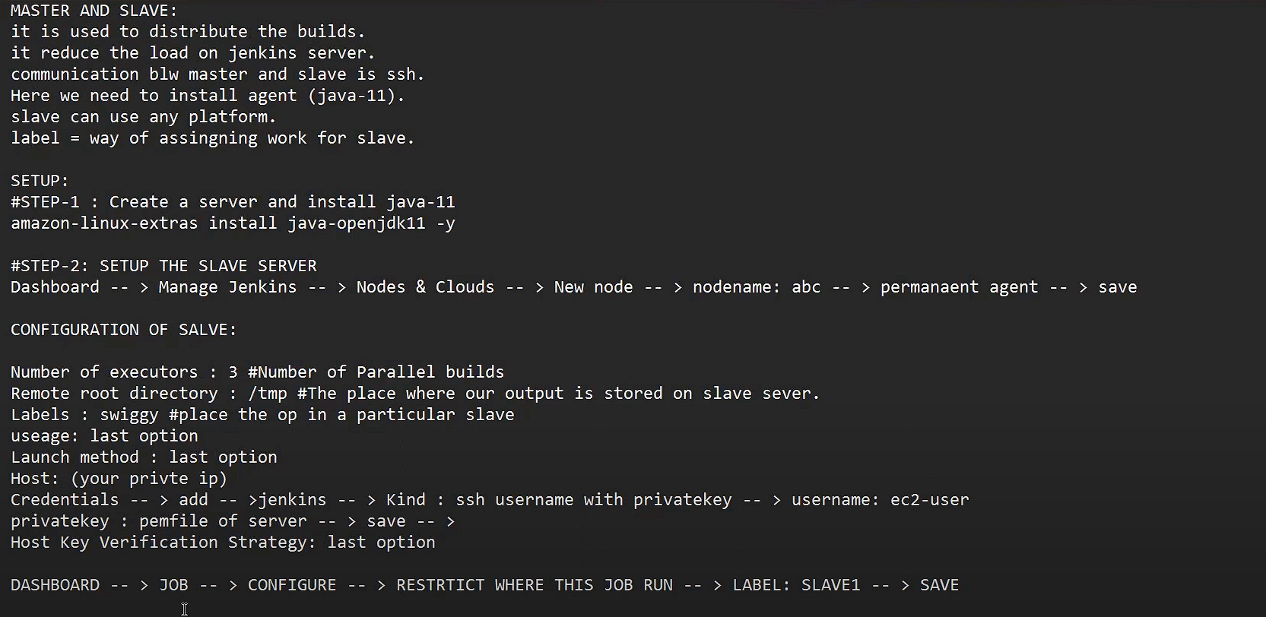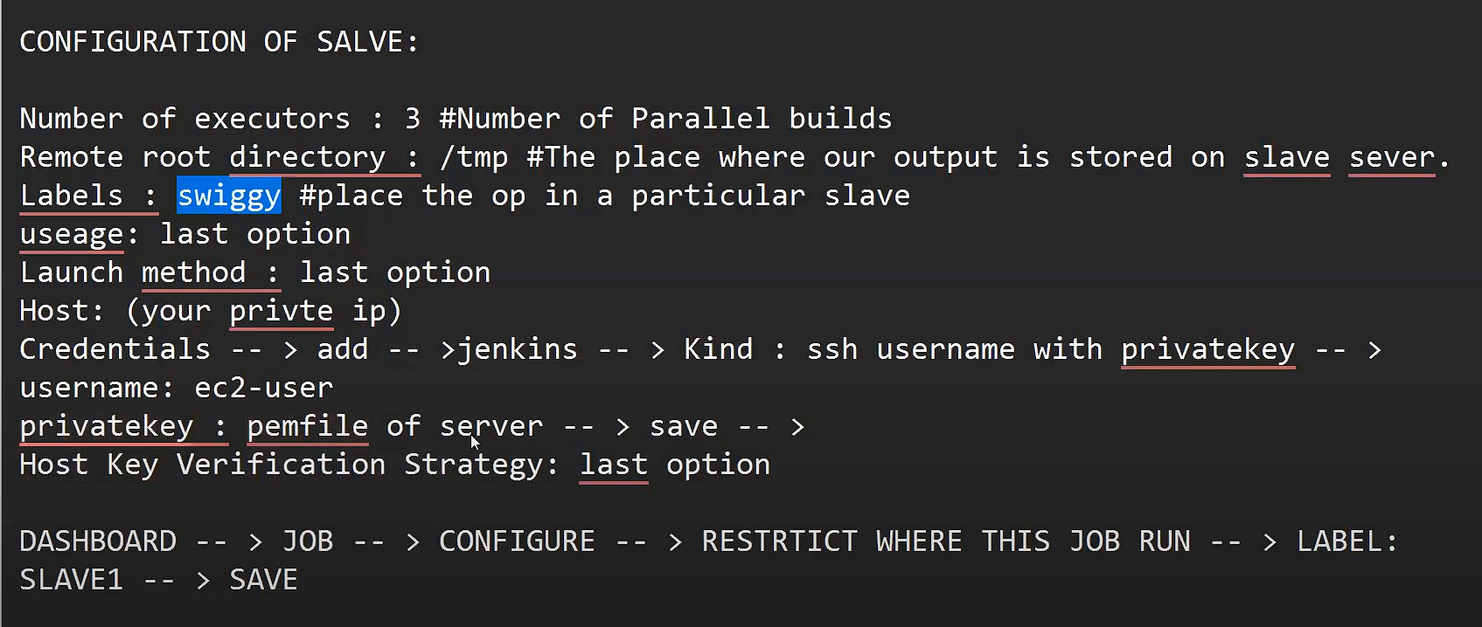

**Note – whenever you make a server make sure to install java maven and git**

**LINKED JOBS :**

**Here jobs are linked with each other**

**Types :**

1. **Up Strean**
2. **Down Stream**

**Create a job 2**

**Job1 - - > configuration -- > post build actions -- > build other projects -- > name of job2 -- > save**

**CLASS 11**

**JENKINS PIPELINE :**

Step by step execution of particular process series of events interlinked with each other

Pipelines ae syntax based

We use Groovy Language to write pipeline.

It’s a DSL (domain specific language)

It gives the visualization pf a process execution .

CODE -- > BUILD -- > TEST - - > ARTIFACT

Types of pipelines :

1. Scripted
2. Declarative – 90 perc we will use this one

**Decorative Pipeline :**

**Single Stage :**

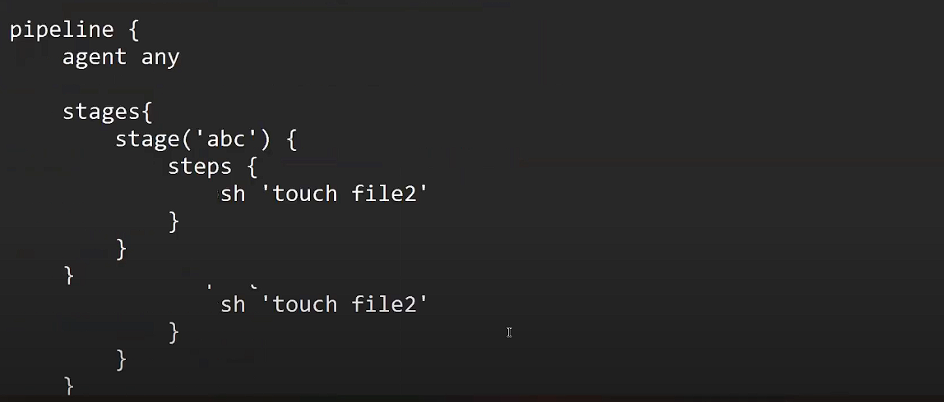

**}**

**Multi Stage :** 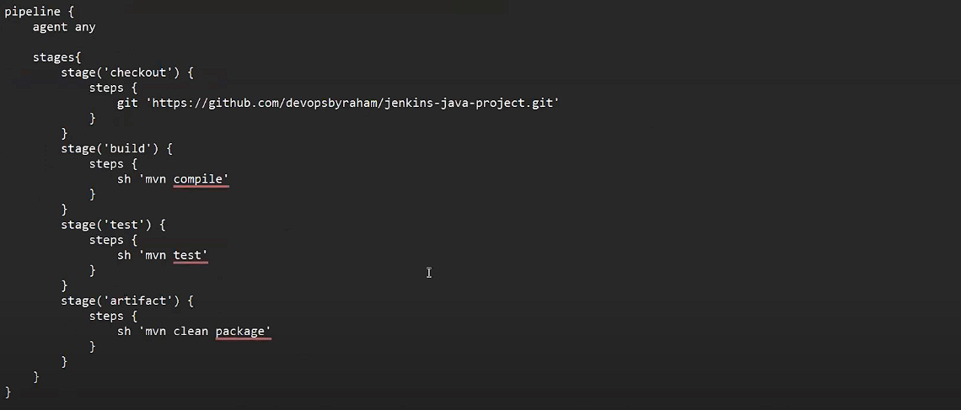

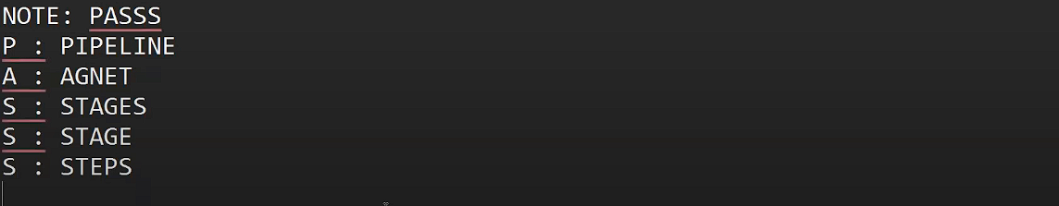

**Pipeline as a Code :**

**Executing multiple commands or multiple actions on a single stage.**

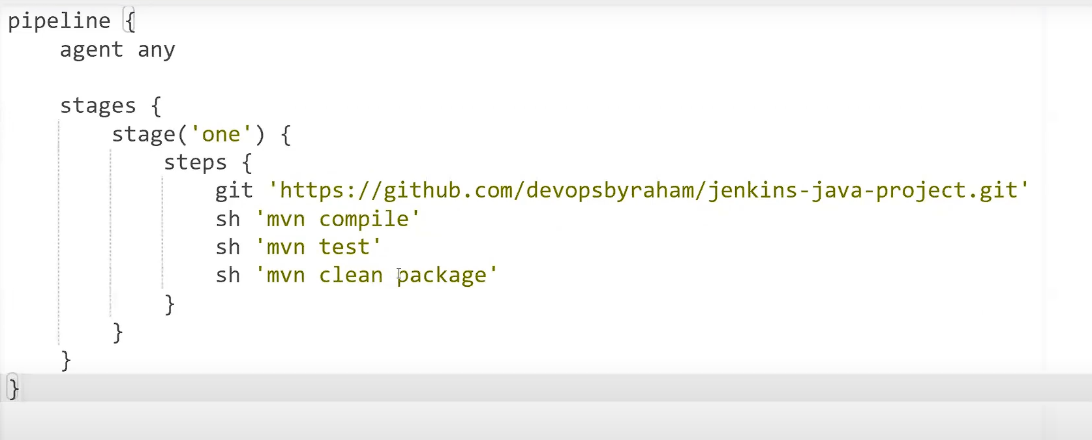

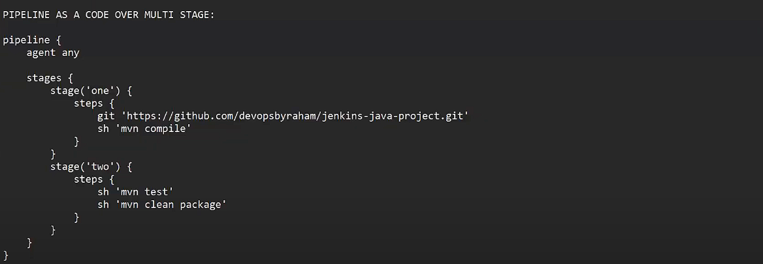

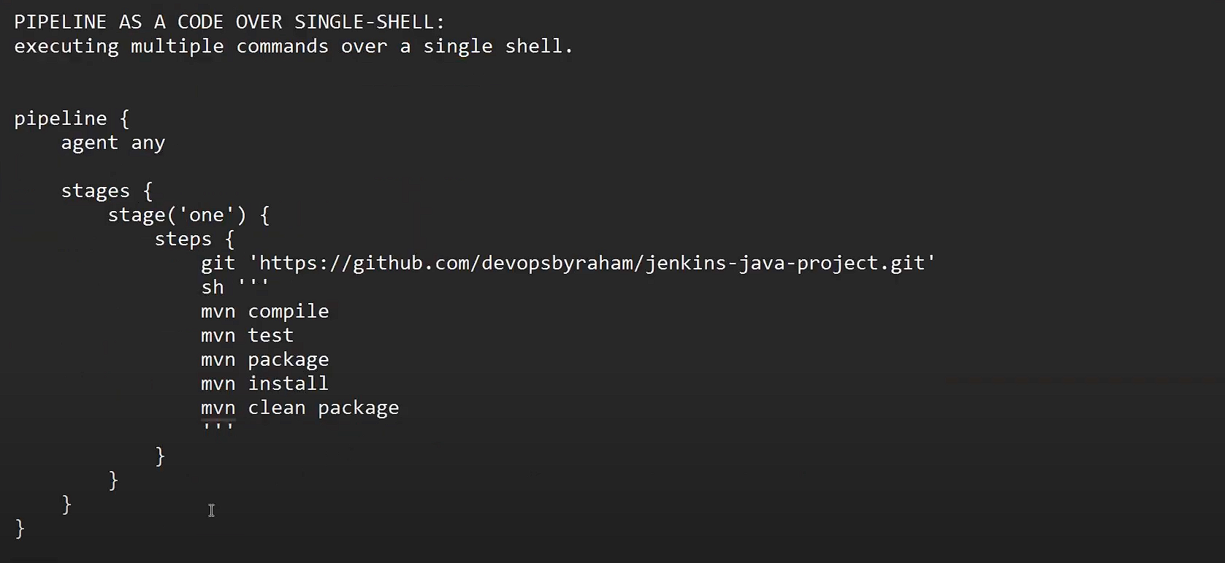

**SONARQUBE :**

It’s a took used to check the code quality.

It covers the bugs, vulnerabilities, code duplications, code smells .

It supports 20+ programming languages

We have both free and paid versions

Port : 9000

req : t2 medium

dependency : java-11

SETUP :

Launch an instance with port 9000 and t2.medium also take linux2 as ami

Run the script: 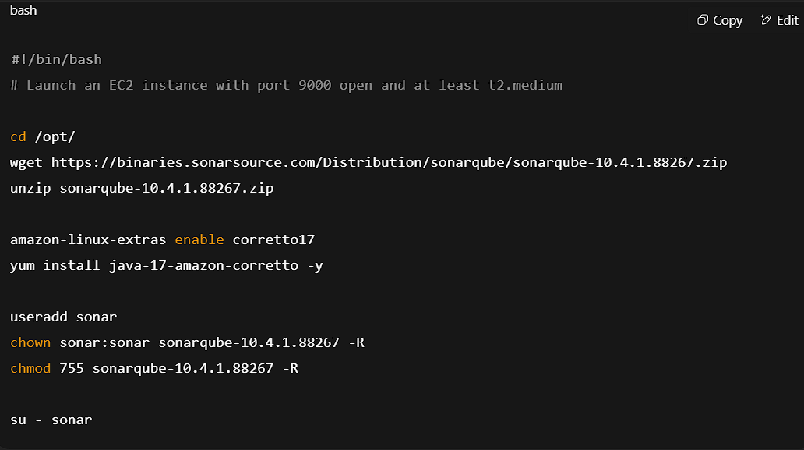

#run thias server manually

#sh /opt/sonarqube-10.4.1.88267/bin/linux-x86-64/sonar.sh start

#echo ‘user = admin & password = admin’ – user these as username and password and then change it

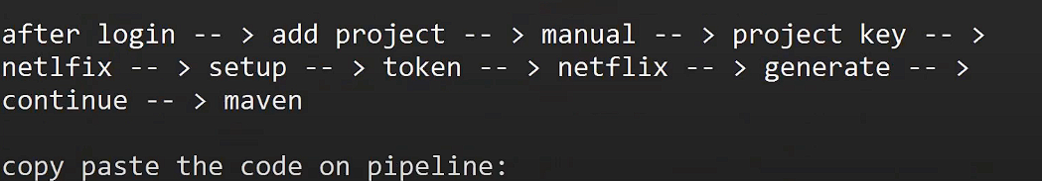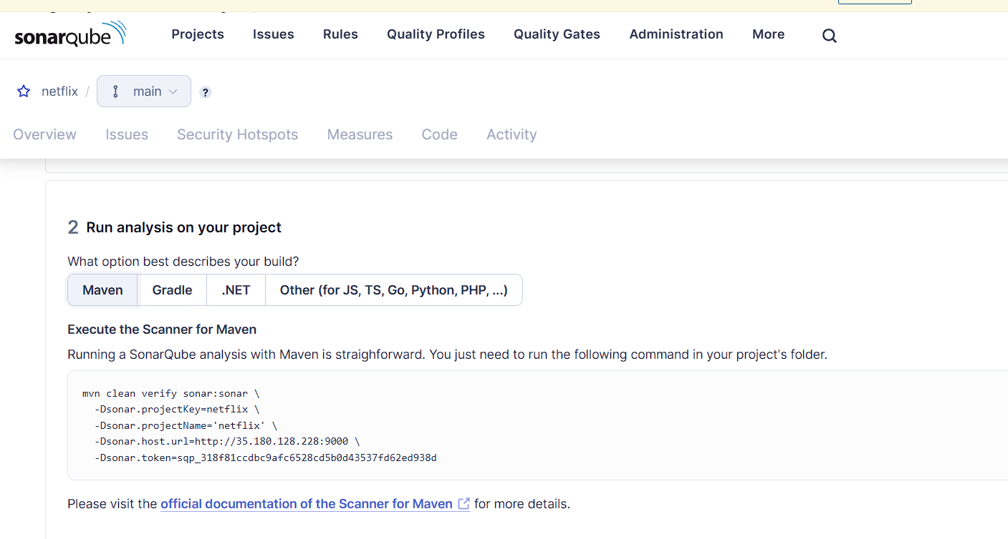

Above the artifact paste the code in satge(‘code quality’) – steps –

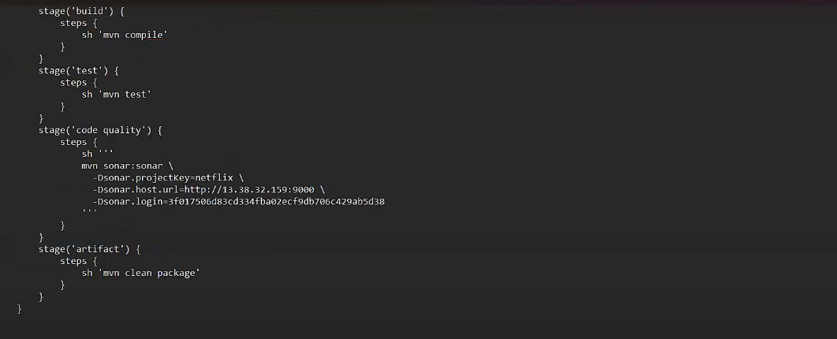

To run pipelinw on slave

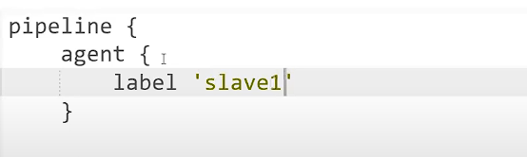

**CLASS 19**

**How to pass variables in a pipeline**

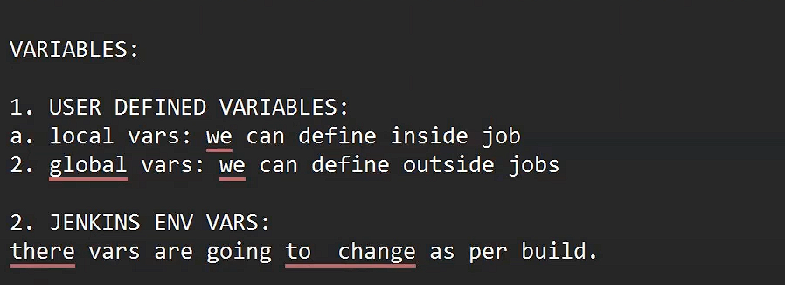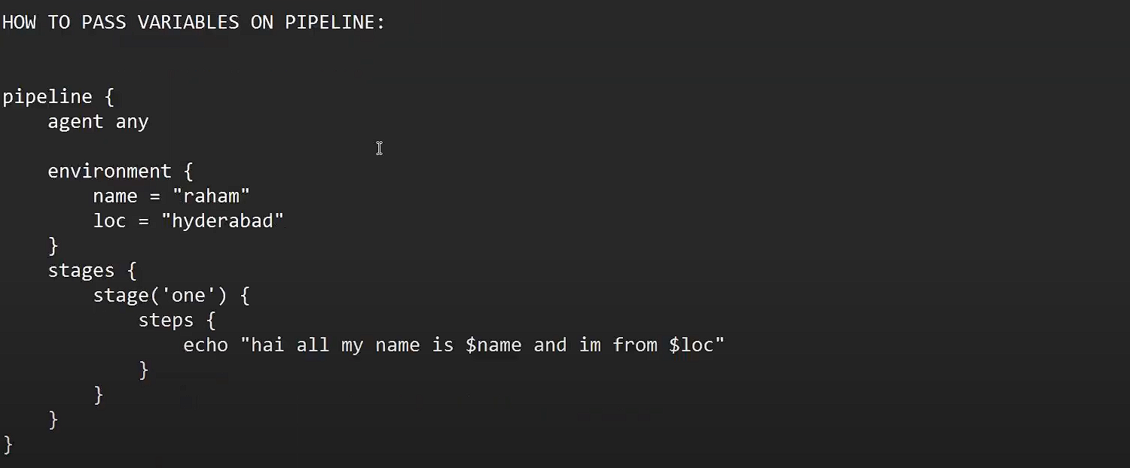

**POST BUILD ACTIONS**

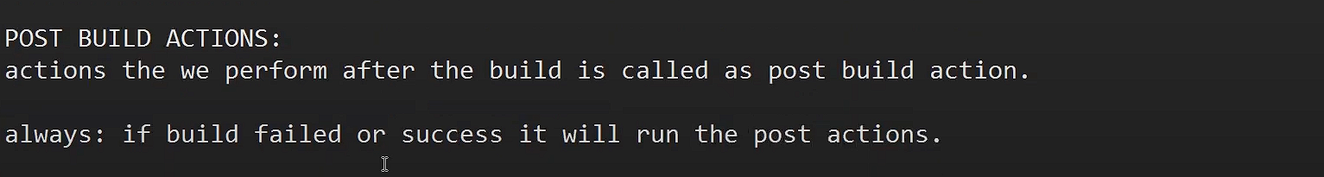

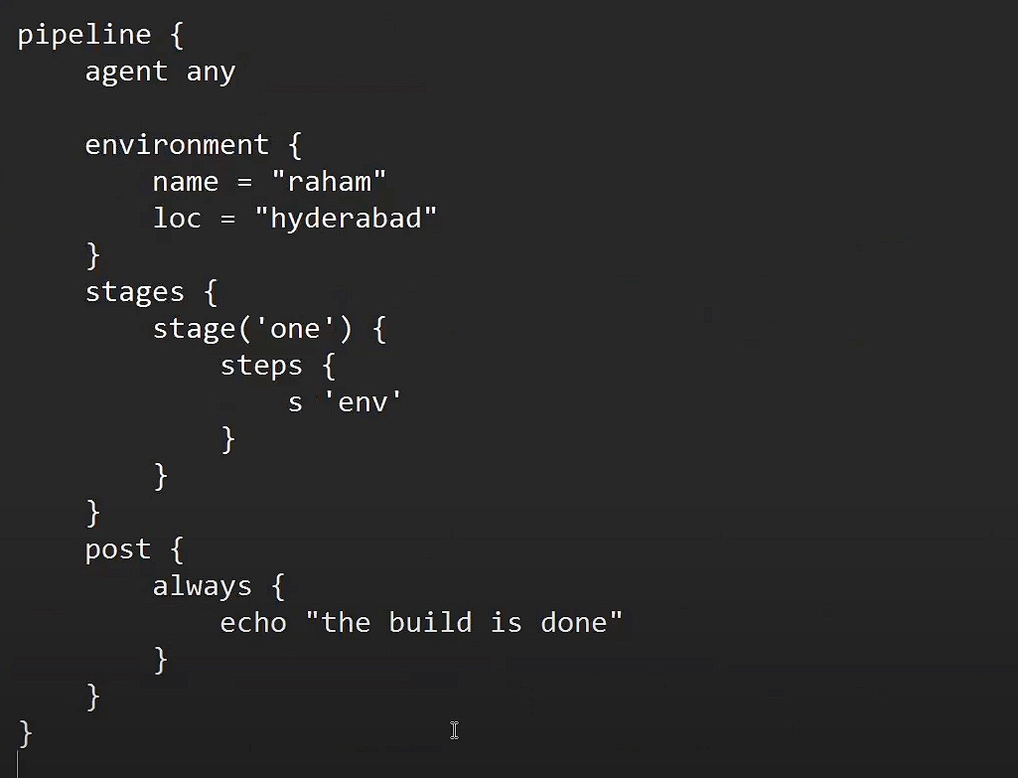



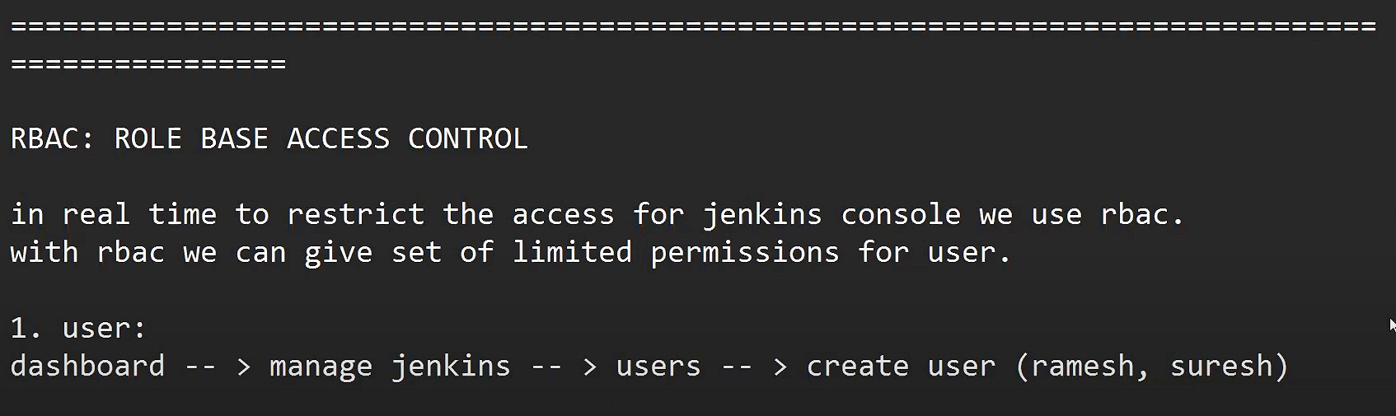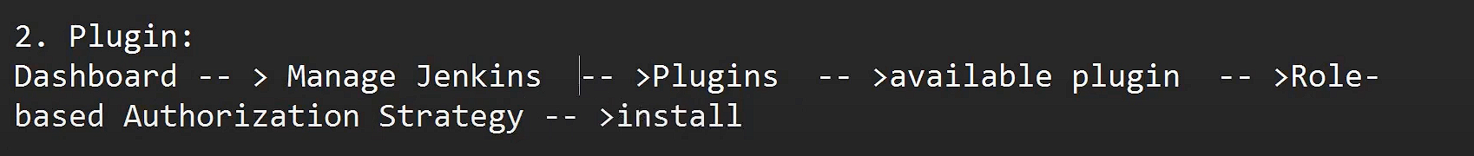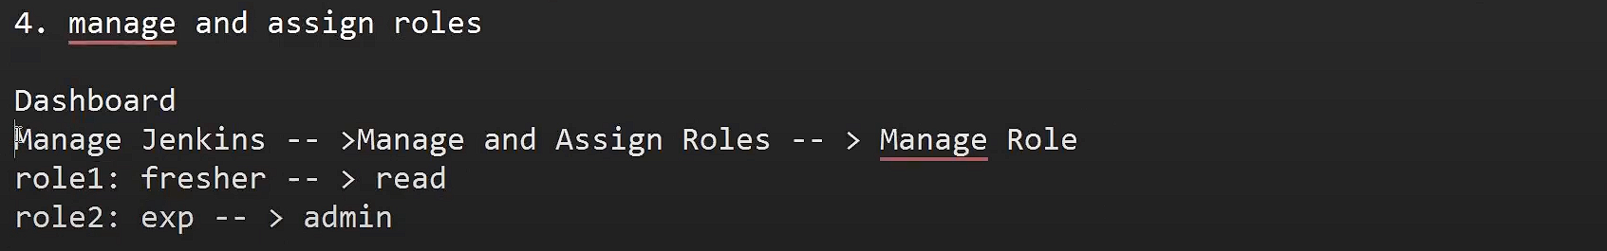

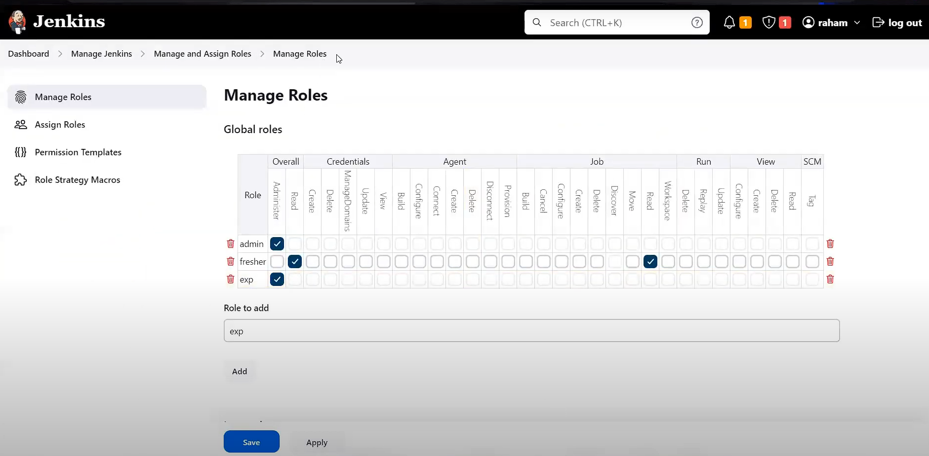

WARNING – while running sonarqube it will got stuck because the server you are running will have not enough memory to run so ask gpt about this problem and ask for swap method

**CLASS 20**

**JENKINS PROJECT  
TOMCAT**

-> search for <https://dlcdn.apache.org/tomcat/tomcat-9/v9.0.106/bin/>

Select the tar.gz

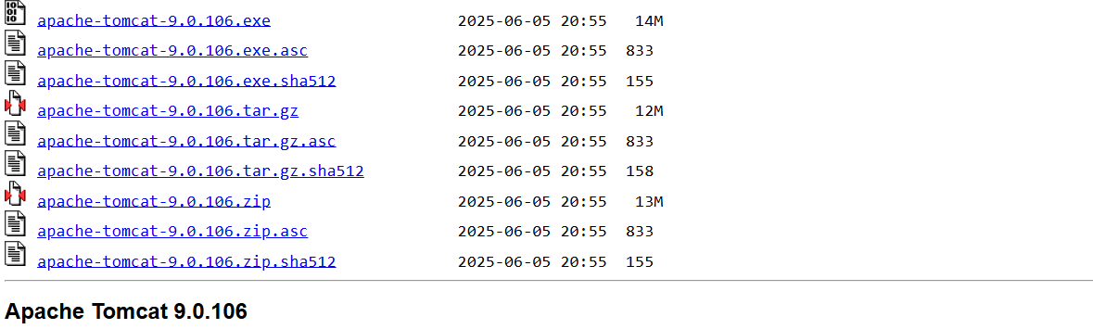

Or

Go to your server and type command

1.downloading

wget https://dlcdn.apache.org/tomcat/tomcat-9/v9.0.106/bin/apache-tomcat-9.0.106.tar.gz

2.antarring like unzipping

tar -xzf apache-tomcat-9.0.106.tar.gz

1. vim apache-tomcat-9.0.106/conf/tomcat-users.xml
2. go to the end of the file using G (shift g) and copy the last 3 lines 

and paste it below arrow like shown  
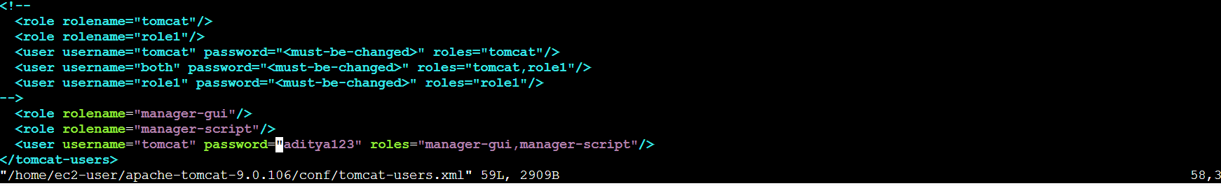 <tomcat-users>

<role rolename="manager-gui"/>

<role rolename="admin-gui"/>

<user username="admin" password="admin123" roles="manager-gui,admin-gui"/>

</tomcat-users>

also change the role name manager-gui again role name as manager-script  
then change the password - > then add the roles as shown

1. again go to one more fille editor  
   vim apache-tomcat-9.0.106/webapps/manager/META-INF/context.xml (delete line 21, 22) why because if we don’t remove that lines we need to give our ip address.
2. 6. sh apache-tomcat-9.0.106/bin/startup.sh - start the tomcat

PublicIP slave:8080  
 

Go to manage jenkins-> pluggins -> avaialble pluggins 

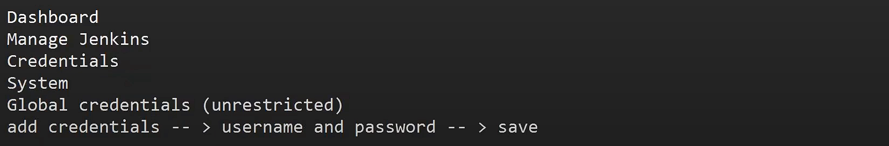

Now to go to credentials and copy the tomcat id 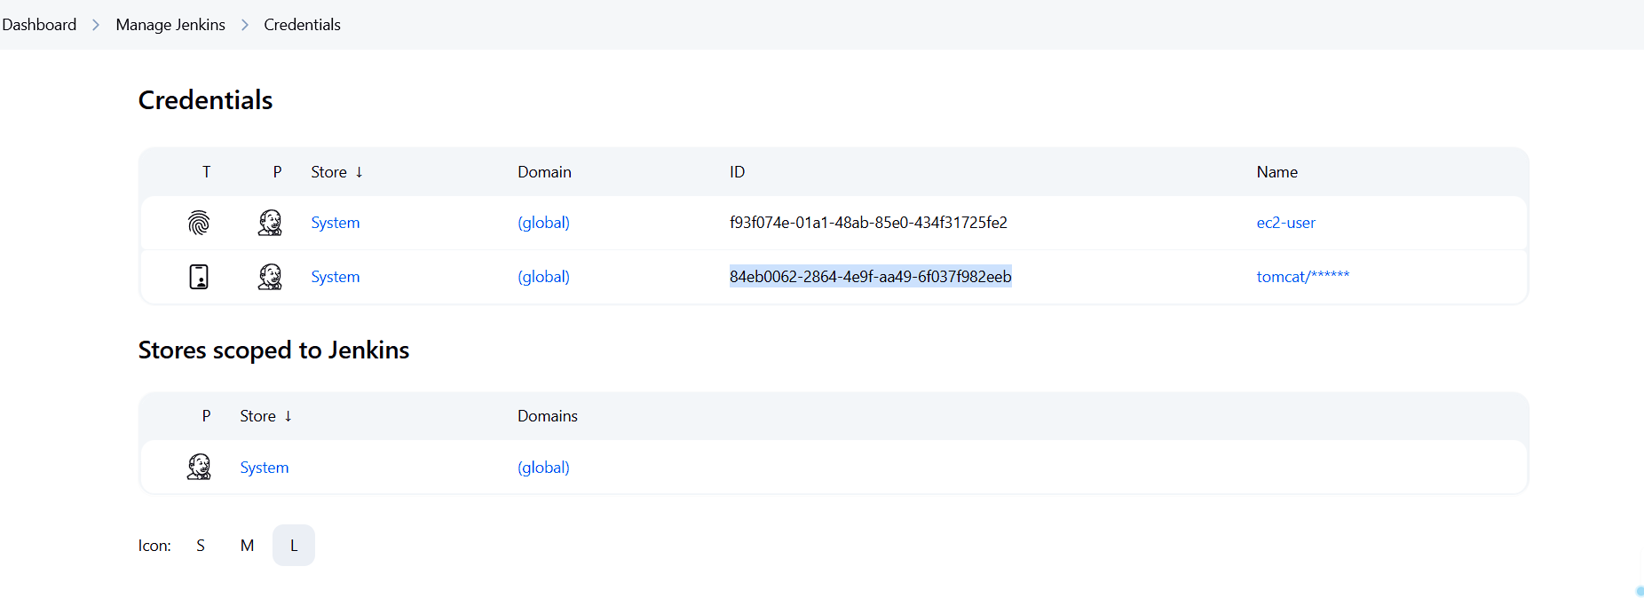 84eb0062-2864-4e9f-aa49-6f037f982eeb

Writte the pipeline like this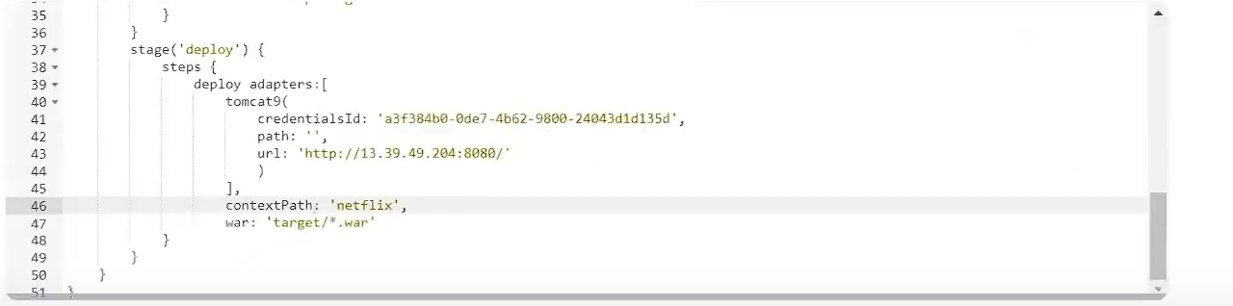

url will we your tomcat url : http://51.44.19.26:8080/netflix/

TROUBLESHOOTING TECHNIQUES :

1.SERVER LEVEL

2. JOB LEVEL

3. CODE LEVEL – developer I responsible

1. SERVER LEVEL :

a. conole output – check console output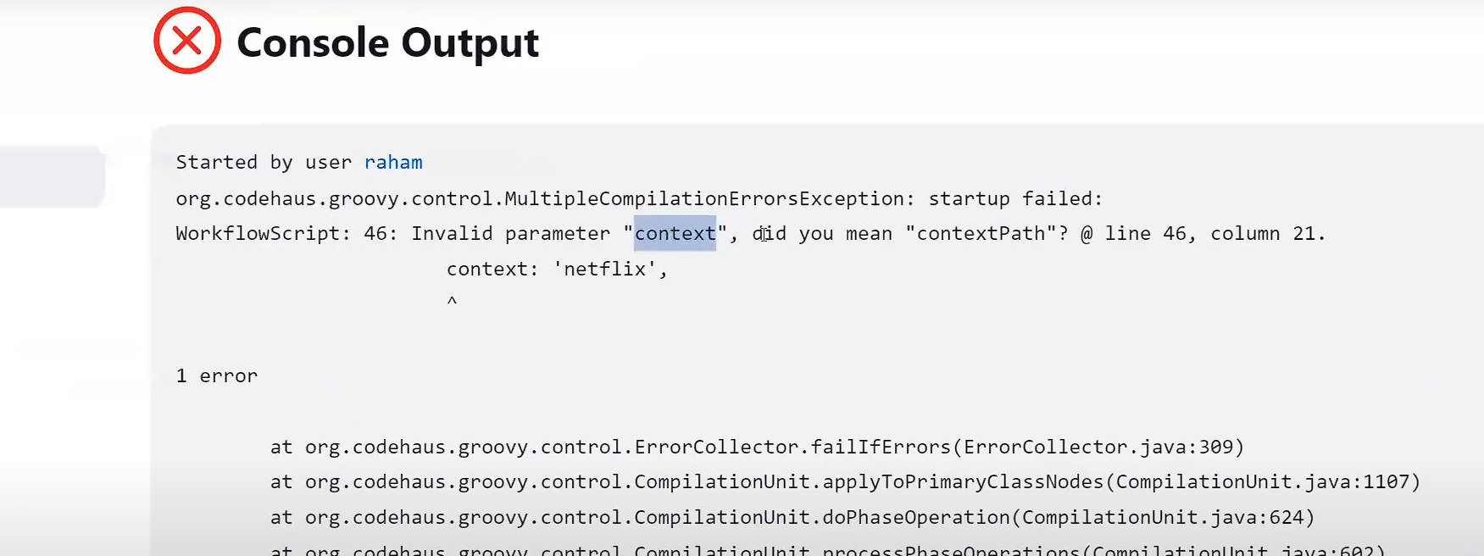

b. maven and java check on server

c. dependency mistakes

d. cpu and memory consumption – if its running out of space

2. JOB LEVEL TROUBLEHSOOTING :

a. repo and branch config

b. syntax

c. plugins

TIP : how to change port no of tomcat

Go to vim /root/apache-tomcat(hit tab) /confg/server.xml

Got to :69 line 69 and change the port no

Shutdown using script and then restart